**Data Flow Diagrams:**

Project Design Phase-II

Data Flow Diagram & User Stories

|  |  |
| --- | --- |
| Team ID | PNT2022TMID01720 |
| Project Name | Smart waste management system for  metropolitan cities |
| Maximum Marks | 4 Marks |

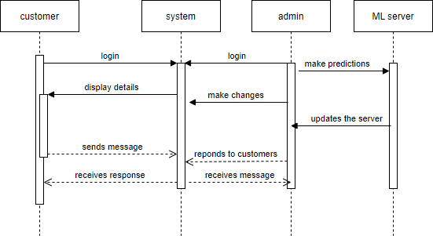

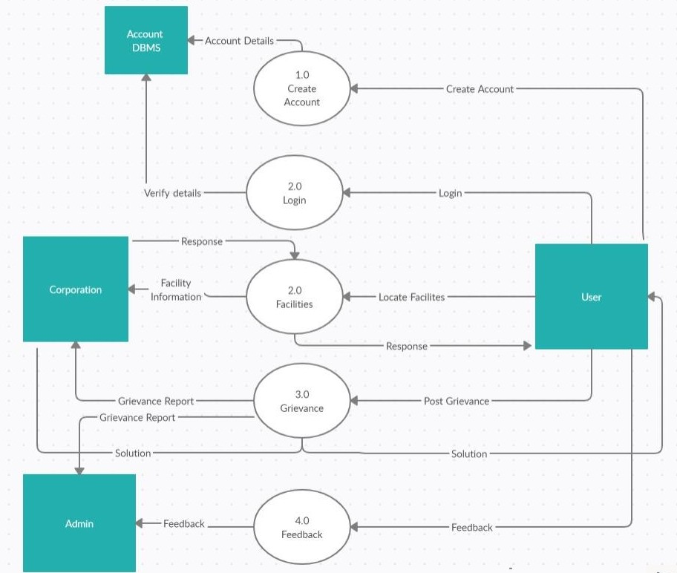

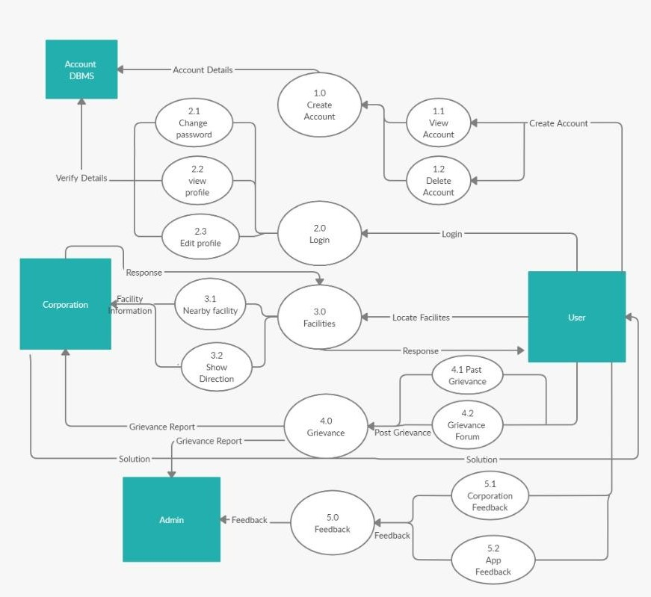

**User Stories**

Use the below template to list all the user stories for the product.

|  |  |  |  |  |  |  |
| --- | --- | --- | --- | --- | --- | --- |
| **User Type** | **Functional Requirement (Epic)** | **User Story Number** | **User Story / Task** | **Acceptance criteria** | **Priority** | **Release** |
| Customer (Mobile user) | Registration | USN-1 | As a user, I can register for the application by entering my email, password, and confirming  my password. | I can access my account / dashboard | High | Sprint-1 |
|  |  | USN-1 | As a user, I will receive confirmation email once I have registered for the application | I can receive confirmation email & click confirm | High | Sprint-1 |
|  |  | USN-3 | As a user, I can register for the application  through google & facebook. | I can register & access the  dashboard with Facebook & google Login | Low | Sprint-2 |
|  |  | USN-4 | As a user, I can register for the application  through Gmail | I can create new account  & access it | Medium | Sprint-1 |
|  | Login | USN-5 | As a user, I can log into the application by  entering email & password | I can access my  account/dashboard | High | Sprint-1 |
|  | Dashboard | USN-6 | As a user, I can locate the bin | I can view the location of the bin | High | Sprint-1 |
|  |  | USN-7 | As a user, I can access data of the bin | I can search a bin and view all details like bin  id,location, bin level | High | Sprint-1 |
|  |  | USN-8 | As a user, I can post queries | I can post queries that our locality face in order to overcome that | Medium | Sprint-2 |
|  |  | USN-9 | As a user, I can provide Feedback | I can provide feedback  about the app | Medium | Sprint-2 |
|  |  | USN-10 | As a user,I can interact with chatbot | I can interact with chatbot for assistance | Low | Sprint-2 |
| Administrator | Dashboard | USN-11 | As a user, I can view grievance | I can view the grievance  posted by the user | High | Sprint-1 |
|  |  | USN-12 | As a user, I get alert | I can get alert once the bin is filled | High | Sprint-1 |